A children's musical

Dr. Ralf Hardenberg (lyrics) and Robert Eilers (music)

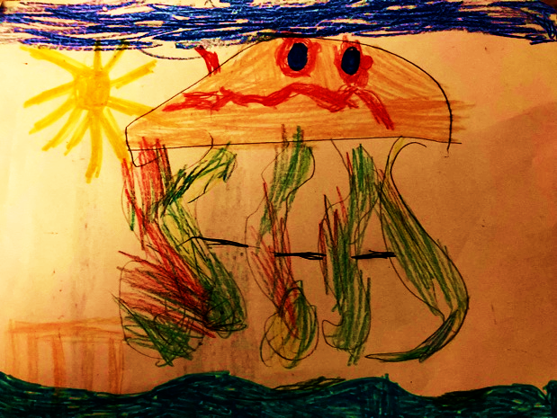

Lise Paldanius, aged 4

What it's about:

Turtles live peacefully in the ocean.
The Hempel family lives in their rubbish.
The rubbish has to go!
Entrepreneur Dreckweg has the solution:
His rubbish girl Isa collects the rubbish
and disposes of it in the sea: in no time at all – rubbish gone.
The ocean and its inhabitants are suffocating in rubbish.
But Isa and Nele, the Hempels' daughter, become friends
Children demonstrate and change the world.
The future arrives and reveals: in 2050, there will be no more rubbish in the sea.
People have avoided plastic, recycled it,
reused it, reduced waste and cleaned up the oceans.
In the present, the children rejoice and celebrate.
In 2050, the oceans are clean again and life returns.

The musical is part of the educational work of "End Plastic Soup", a global Rotary initiative that has set itself the goal of eliminating the large oceanic garbage patches by 2050 – encouraging people to use the Earth's resources responsibly. For future generations.
Listen to your children!

All information:
https://drive.google.com/drive/folders/15uZvXQ45h1p8fGW7ovTOC-B4KfGCvi_l?usp=sharing

Table of contents
Scene 1: The turtles and the sea 5
01 The sea 5
02 Vastness, Depth, Silence 5
03 Growing up 5
04 Oh, Mother is dreaming again 6
05 Snap, beak! 6
Scene 2: The Hempel Family 8
Scene 3: Retreat – Clean Up 10
06 Quick, quick, dirt away! 10
07 Stop! - instrumental 12
Scene 4 – Disposal 12
07 instrumental (short) 12
08 Stop it, right now! 12
Scene 5: Nele and Isa 13
09 Dirt-away girl 13
10 You were missed (Isa's song) 14
Scene 6: The demonstration 14
11 No more plastic 15
Scene 7: The Future 15
11 a Enter the Future 15
12 Plastic in the Sea 15
13 See you later! 16
13 a Music: Rhythm Song 06 (drums only) 17
Scene 8: Present and conclusion 17
14 Voice-over to song no. 14 "Floating, living" 17
15 Listen to me 19
16 Dance until you're back at the front 19
Applause music Snap, snap, beak (instrumental, see 05 above) 20

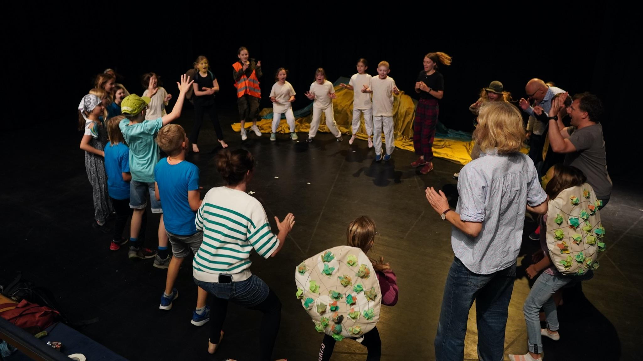

Scene 1: The turtles and the sea

Children gently move a blue parachute up and down in waves, imitating the movements of the sea.
Gradually, the turtles appear.
Children play in the sea. Parents watch their children with pride.

01 The sea
Mother: Look around you, children, look at this world, the vastness, the depth, the silence here in our world.

02 Vastness, depth, silence
Mother: Up and down, the waves lift us in the sea. Then let us sink, floating back and forth.

03 Growing up
Turtle children appear one after the other. Spoken. Turtle child 1: We turtles hatch from the egg and wander into the sea. Turtle child 2: We are one with each other, with life in the ocean.
﻿Turtle 3: We are this ocean, inseparable, one life. Enjoy life, it means so well by us. All: It really means so well.

﻿Children (1st voice) We grow up, we grow older, we grow up and grow older, we become parents and grandparents. Hatch, finally out of the egg, hatch, finally it breaks in two. Dig, dig, dig yourself out, quickly out of the egg!
We grow up, we grow older, we grow up and older, we become parents and grandparents. Sch. 2: Hatch, finally out of the egg, hatch, finally it breaks in two. Dig, dig, dig yourself out, quickly out of the egg! We grow up, we grow older, we grow up and older, we become parents and grandparents.
A smart aleck (spoken): Exactly. Even grandparents!
Sch. 1: Keep digging, keep digging, out of the egg.
Sch. 2: Keep going, Sch. 3: keep going.
Parents (1st voice): Float, live, float, live, float, live, float, live. Down with the waves, up with the waves, down with the waves, with the waves. With the waves. We grow up, we grow older, we grow up and older, we become parents and grandparents. We grow up, we float, we live.
Children (2nd voice): Floating out to sea with the turtles, living. Floating out to sea with the turtles, living. Down with the waves, up with the waves, down with the waves, with the waves, with the waves. We grow up, we grow older, we grow up and older, we become parents and grandparents. We grow up, we float, we live.

04 Oh, Mother is dreaming again
﻿Children: Oh, mother is dreaming again, this is our chance. We'll play at disappearing and hiding and then scaring our parents, let's get up to mischief and discover the wide, wide world, disappear and hide and then scare our parents,
and we're up to something, after all, that's our name, we swim on our backs, on our stomachs and anyway. We play at disappearing and hiding and then scaring our parents, let's get up to mischief and discover the wide, wide world, disappear and hide and then scare our parents,
and we're up to something... later, much later, we'll reappear.
Mother: Children, where are you? Remember the sharks, they're especially hungry today.
Think of the seagulls, they're particularly annoying today. Think of your armour, it's not that strong yet. All children (spoken): Yes, Mum! Later, much later, we'll reappear.

All the children dive under the water.

The parents stand alone, worried: Children, where are you? Think of the sharks, they are particularly hungry today. And the seagulls...

Father and mother exit.

Rearranging work in the background – the ocean stage set is transformed into the Hempel family's flat. Lights out.

Seagulls from offstage:

We are soooo hungry! Is there nothing to eat here?
We're hungry, we're hungry!

05 Snap, beak!

Two little turtles without shells look around fearfully. A voracious seagull peeks out from behind the curtain.

Voracious seagull: Well, well!
Seagull cousins 1 and 2: Snap, beak!
Greedy seagull: There's something to see here!
Seagull cousins 1 and 2: Snap, beak!
Greedy seagull: Well, well!
Seagull cousins 1 and 2: Snap, beak!
Greedy seagull: Can't resist! A sweet little breakfast! No shell, no bones! I've got to take a look at that bite!
Go ahead, go ahead!
Seagull cousins 1 and 2: Snap, beak!
Greedy seagull: Go on, go on!
Seagull cousins 1 and 2: Snap, beak!
Greedy seagull: I'm already hungry! Go on, go on!
Seagull cousins 1 and 2: Snap, beak!
Gluttonous seagull: Yes, my favourite are small, tender toads that blush before me, open your beaks, I'm taking you now!

Seagull cousins 1 and 2: Beak, snap, beak, snap, snap!
Gluttonous seagull: Beak, snap, beak, snap, snap!
Seagull cousins 1 and 2: Beak open, beak open!
Beak, beak open! Beak open,
beak, snap, snap!

Greedy seagull: Go on, go on!
Seagull cousins 1 and 2: Snap, beak!
Greedy seagull: Now snap at last.
Seagull cousins 1 and 2: Snap, beak!
Greedy seagull: Me first or you? We'll grab the toads, they won't get away. I'm not going to miss this bite.

A friendly seal appears.

Seal:
There's nothing to see here!
Please don't stand here!
Listen, I'm much stronger than the three of you!
So let the toads go now!

The little toads breathe a sigh of relief. The seagulls retreat, disappointed.

Toad 1 (spoken): Ouch, that was close! Maybe I should listen to Mum after all! What do you think?
Toad 2 (spoken): You're right. I think so too.

The friendly seal wraps its flippers around the little one, lovingly concealing her, and swims away with her, smiling and winking.

The seagulls screech indignantly (making a big fuss):

Seagull cousins: We're hungry, we're hungry!

Voracious seagull: Where has she gone, the little one?
Gone is the tender, soft, delicate one.

All: Aaaah – Screech!
Snap, snap, beak,
Forever empty beak.

The seagulls leave, the lights come on and the Hempels' flat with all its rubbish becomes visible.

The seagulls look curiously into the Hempels' living room and covet the rubbish, but are chased away by the mother: shoo, shoo. Seagulls exit.

Scene 2: The Hempel family

Living room with sofa, table, armchair and chair – all made of plastic – plastic rubbish everywhere. Set change, the "sea" is pulled back – revealing the Hempels' furniture – and plastic rubbish everywhere.
Initially, spotlight on Nele.
Then lights for the entire living room. Father, mother and son Ottokar enter noisily.
Daughter Nele sits reading a book on her little stool. Father Hermann and his son Ottokar lounge on the sofa. Mother Maria walks around, lost in thought, cleaning.

Father:
Hey, Otto, dear Otto:
get me a fresh,
ice-cold, sugar-sweet Coca-Cola!
This bottle is empty again.

Ottokar (mimicking his father):
Otto, dear Otto! Father, dear Father – go and get her yourself!

Father:
Oh Otto, oh Otto, how dare you speak to your father like that?
Now quickly, get up and obey!

(Turning to Nele):
Nele, what are you doing, quiet little Nele?
Oh dear, this overly clever girl sits around
Sitting silently as always and reading.
Yet she knows:
Reading confuses the mind,
Reading makes you stupid!
Put that book aside immediately,
go and get your thirsty, exhausted father
a fresh, ice-cold, sugar-sweet Coca-Cola!

Mother:
Calm down, calm down! I'm getting somewhere.
Now, there, I can feel it clearly:
Here it comes: a thought.

Father:
Oh God, a thought. Not another thought.
This is going to be bad, really bad. Don't listen!

Ottokar:
Oh no, a thought. But what are you thinking?

Mother:
Ah, it's more than a thought.
Now I know for sure:
It's an observation, a perception.

Father and Ottokar:
What is it then?

Mother:
The rubbish bin is full!

Father:
Rubbish bin, which rubbish bin?

Ottokar:
There isn't one. I don't see any rubbish bin!

Mother:
There's so much rubbish lying around here,
so much, everywhere, all around,
that we can't see it anymore.

Father:
Then how do you know it's full?
Above all, Mum:
What's the problem? I don't see a problem.

Mother:
Hush! I'm about to have another one. I can feel it clearly, very clearly.

Father and Ottokar:
Oh, no!

Mother:
An assessment and a decision.

Ottokar:
That's two things again,
isn't one assessment enough?
What do you want now?

Mother:
Firstly, there's too much rubbish and, secondly, it has to go!

Nele:
Too much rubbish? It has to go, but where?

Father:
Be quiet, Nele!
Silly question.
The rule is:
If Mum says there's too much rubbish, then there's too much rubbish.
If Mum says it has to go, then it has to go.

I'll call the rubbish contractor Dreckweg,
Heinrich Dreckweg, whom I know well
and his rubbish girl, Isa, too.

They come, take all the rubbish away, and that's it!
Away with plastic. They'll take care of it.

Hey, Otto, dear Otto:

Get me a fresh, ice-cold, sugar-sweet Coca-Cola!
I'm really thirsty from all this thinking and talking.

Scene 3: Retreat – Clean Up

The doorbell rings and Heinrich and Isa enter the Hempels' living room. Light on Heinrich and Isa, later light on the entire stage.

06 Quick, quick, clean up!
﻿Heinrich (speaking freely, loudly and intrusively, rapping): Hello, everyone, have a wonderful day. It's nice here, lovely flat. Allow me to introduce myself: I'm Heinrich and this is my rubbish girl Isa. Our company is called Ruckzug-Dreck-Weg. How can we help?
﻿Father (spoken): Good that you're here. The dirt has to go. It's urgent, so we can all have our peace and quiet again.
Heinrich (spoken): No problem. We'll take care of it, and then the rubbish will be gone.
﻿Ruckzug, Dreck weg, the dirt is gone in no time! Hello, my friends, have a wonderful day. We do the job that none of you like to do. This is our company, our name says it all. We dispose of twenty tonnes or a hundred grams. We dispose of plastic waste, you won't see it again soon, don't worry, we'll empty all the bins! Retreat, dirt gone, in no time at all, the dirt is gone! Just give me the dough and sit back!

Heinrich:
Isa, put the rubbish in our bags, in less than an hour everything will be out of the house.

Isa packs the rubbish into the bags.

Heinrich:
Disposal is, you know, not cheap.
Give me money, lots of money! Nice, clean money.

Father Hempel gives him money. Mother Hempel gives him more money.

Heinrich:
All right, that's enough for today. Rubbish gone,
mother happy, see you next time.

Nele: Where are you taking the rubbish?

Heinrich:
That's nobody's business,
we take the rubbish with us and dispose of it.
Then it's gone. You won't see it anymore.
Now you can see your dustbin again,
go shopping again, accumulate mountains of rubbish again.
Then we'll come back, again and again,
take your filth away, over and over again.

Father:
That's right, and don't ask such stupid questions, Nele!
Heinrich, as you suggest, so it shall be,
you have the money, you earn the money,
if we don't see any rubbish, there is no rubbish.

Nele: Where are you taking the rubbish?

Renovation – the flat disappears, the cloth becomes the ocean again.

07 Stop! – instrumental

Scene 4 – Disposal

Heinrich and Isa are standing on the beach. They have the bags of the Hempels' rubbish with them.
Nele watches the scene from hiding.
Heinrich and Isa begin throwing the rubbish into the sea.

Heinrich (to the audience):
It's a huge, enormous business:
we collect the rubbish, get paid well for it,
and then, watch this: this is the best part,
we throw all the rubbish, bang: into the sea.
It costs nothing.

07 instrumental (short)

It's a huge, enormous business,
because the sea, the great sea, is silent.

Choreography during song 07 Stop: Isa throws the rubbish into the sea. At first, the little turtles come curiously and play with the rubbish, throwing bottles to each other and laughing, but their parents call them back sternly. More and more rubbish ends up in the sea, the turtles' home, until all the rubbish bags are empty and the sea is so full that the animals have no room left.

Nele:
What are you doing here?
This is the turtles' home.
You can't just throw rubbish into the sea.
Don't you know how much rubbish is already floating around in the sea?
Rubbish covering an area the size of Europe is floating there,
poisoning everything, not decomposing for a thousand years,
appearing and disappearing with the currents.

Nele sings and gradually the choir joins in

08 Stop, immediately!
﻿Group 1: Stop, immediately, the sea is dying! Stop, immediately, the sea is dying!
Stop, immediately, stop, immediately!
Stop, immediately, stop, immediately!
Stop, immediately, the sea is dying! Stop, immediately, the sea is dying!
Stop! Stop, immediately, stop, immediately!
Stop, immediately, stop, immediately!
Stop, immediately, stop, immediately!
Stop, immediately, the sea is dying! Stop, immediately, the sea is dying! Stop!

Group 2: Stop!
Stop! Stop, immediately, the sea is dying! Stop, immediately, the sea is dying!
Stop! Stop, immediately, stop, immediately!
Stop, immediately, stop, immediately!
Stop, immediately, stop, immediately!
Stop, right now, the sea is dying! Stop, right now, the sea is dying! Stop!

Isa becomes thoughtful, pausing more and more. Heinrich takes over emptying the rubbish into the sea, shrugs his shoulders, and angrily throws another plastic bottle in.

Heinrich:
Let's go.
The little girl is crazy.

The choir withdraws.

Scene 5: Nele and Isa

The sea lies still, full of rubbish.

Isa and Nele stand alone on the stage (beach) and slowly walk towards each other.

Without saying a word, Nele brushes some dirt off Isa, wipes her face clean and begins to brush her hair.

09 Dirt-away girl
﻿Nele: Who are you, girl? Why are you helping? Why are you throwing rubbish into the sea?
Isa: I am the dirt-away girl, I am the dirt-away girl. I am the dirt-away girl, rubbish is my life. I am the dirt-away girl, I am the dirt-away girl, I am the dirt-away girl. Without rubbish, I would be lost. Without rubbish, I would have to die. Heinrich is rich. I have nothing but rubbish. (spoken): I have to help him every day. Collect rubbish, carry rubbish away, dispose of rubbish in the sea. Collect rubbish, carry rubbish away, dispose of rubbish in the sea. Spoken: I have no one, only Heinrich. Heinrich is good to me. Not always, but that's normal, after all: I live, I survive, I live, I survive. I am the rubbish girl.
Nele: She's the dirt-away girl.
Isa: I am the dirt-away girl. Rubbish is my life.
Nele: She's the dirt-away girl, she's the dirt-away girl.
Isa: I am the dirt-away girl. Without rubbish, I would be lost. Without rubbish, I would be lost.

Nele:
Isa, dearest Isa, come to me,
come closer, come closer.
If you want, you've found a friend,
namely me, Nele.
I feel your beautiful, sad heart,
you are much more than a rubbish girl.

Isa:
A friend?
I've never had a friend before.
I'm ugly,
I stink like rubbish,
I'm nothing but rubbish.

Nele:
Dear Isa, stay with me:
You have found a friend,
me, your Nele.

Isa and Nele hug each other.

10 I missed you (Isa's song)
I missed you, I was a fish out of water, it was as if there was no salt left in the sea. I felt like a salmon without gills, like a lonely island, completely empty. But now that I've found you as a friend, I'm so happy, we want to do everything we can for the sea, so that one day the sea will be healthy again, so that the animals in the sea will no longer suffer, so that nothing suffers, so that nothing is missing, so that nothing suffers.

Scene 6: The demonstration

A large, colourful children's demonstration march comes onto the stage from all sides. Children from different countries around the world, with imaginative posters and flags.
The procession comes onto the stage and surrounds Nele and Isa. They are holding plastic bottles in their hands.

11 Stop plastic
Stop plastic and stop rubbish! Let the sea live on! Stop plastic and stop rubbish! Leave the sea alone! Oh, oh. Oh, oh, oh. Oh, stop plastic and stop rubbish! Let the sea live on! Stop plastic and stop rubbish! Leave the sea alone! Oh, oh. Oh,
Spoken: We can do without plastic and packaging. We'll invent something to combat the rubbish in the oceans. By 2050, the oceans must be clean again!
Oh, oh, oh, oh, oh, oh. No more plastic and no more rubbish! Let the sea live on! No more plastic and no more rubbish! Leave the sea alone! Oh, oh. Oh.

Scene 7: The future

Joint moonwalk performance by the three futures. Accompanied by futuristic sounds.

11 a Performance Future

Future 1:
Hello, hello, dear people!
Yes, I don't believe it,
we can't believe it:
How young you all are!

All Futures: Hello, hello: it's us, your future.

Future 2 (whispers): It's 25 years later.

Future 3:
Our name is Two Thousand and Fifty.

You won't believe what has happened in the meantime.
Insane, unbelievable, but true.
We know it for a fact.

All futures: Because we are the future.

12 Plastic in the sea
Now we can reveal it, everyone has understood. We had to wait a long time, but we children have done it.
The plastic in the sea, all the toxic waste, will no longer multiply, because nobody wants that.
It has almost disappeared, except for this bit that I found here, we're about to have a party.
The plastic in the sea, all the toxic waste, will no longer multiply, because nobody wants that.
There is no more plastic in the sea. Plastic in the sea: that's over!

The three futures are busy going back and forth.

Future 1:
Unfortunately, we can't tell you everything.
We have to be brief,
even though there is so much to tell.
We'll tell you! Unbelievable, but true!

Future 2:
You children are all grown up now,
have careers, families, children of your own.
You are so wonderful,
you have contributed so much
to a better future.

All futures: Just us.

Future 3:
We are proud of you. It worked!
The plastic waste in the sea is gone, the plastic soup has disappeared.
You did it, you convinced the adults.

All three:
The oceans are clean again, and in all seriousness,
we know this because we are the future,
the animals have returned,
have recovered, enchanting the sea.

Future 3: We're done, we've told everything.

Future 2: It's incredible how young they all still look!

All futures: See you later!

13 See you later!

The galactophone rings. Future 2: Excuse us, we have to answer the galactophone quickly. Future 1: "Two thousand and fifty here, how can I help you? Okay, we'll take care of that, no problem at all, everything's running smoothly, no mistake about it! Future 1 (spoken): Well, that was obvious!
Both: You really wouldn't believe how young they look here today. No one believes me when I tell them. Future 1: "Yes, yes, we'll get it done, and we'll hurry up too. Both: We have to go now, see you soon, goodbye!"
The galactophone rings. Future 1 (spoken): Who's calling again?
Future 2: Sorry, we have to answer the Galactophone for a moment.
Future 1: "Two thousand and fifty here, how can I help you? Yes, yes, we'll take care of it, no, no, there's no problem, everyone knows exactly why who is doing what and when. Future 2: (spoken): My God, she's annoying.
Both: Of course, the people still look very young. They haven't aged, no, they're still doing well.
Future 1: My boss wants to see me, so I'm afraid I have to leave now.
Both: We have to go, see you soon, goodbye!
Future 3 (spoken): See you later!

Heinrich, the Dreckweg entrepreneur, appears visibly aged.

Heinrich:
Do you know who helped save the oceans? (He points to himself.) When my wife had another idea, I had one too: a thought, an observation, a perception, a decision and – an invention. The gigantic, unique, sensational, phenomenal Heinrich Dreckweg plastic shredder.

13 a Music: Rhythm Song 06 (drums only)

Heinrich demonstrates his invention in action. With this invention, we have helped to save the oceans. You're amazed, aren't you? All I can say is: millions and millions.
But now: back to the present! (He exits laughing.)

Scene 8: Present and conclusion

14 Voice-over to song no. 14 "Floating, living"

Water is clear, everywhere nearby
Water is simply wonderful!
We love the wet stuff,
It's so much fun!

It is quiet in the lake in the moonlight,
In the stormy ocean, it rages loudly.

It drips and hisses, it murmurs,
It rushes, it runs, it ripples

Sometimes peacefully, sometimes with destructive force,
Creating space and destruction for life.

Water is the cool freshness in the lake,
Water is white in the winter snow,
Water is the rain that drips,
knocking pleasantly on our windows.
Water is warm in the bathtub,
Water cleanses, as ice it is smooth.

You baptised us with water, it is holy,
water plunges into the valley, roaring, rushing.
Water forms the tears we feel,
our parents see us, comfort us, feel us.

Your corrosive rubbish floats in the water.
Just look: it's getting worse and worse:
Disposed of by the tonne in the sea,
A destroyed future that we have borrowed.
Water is becoming a murky, deadly poison,
Our oceans are totally polluted.
Plants and animals are dying,
Is this really what you want to leave us?

Water is wet, water is fun!
Water is clear, water is wonderful!
We jump in with a squeal.
We think it's great, totally fine.
Our bodies swim,
slide like slippery fish
through the bright, clear freshness.
Your plastic brings death,
terrible, agonising misery.

All life began with water,
You find it in every cell, every organ,
Without water, no life can
On our beautiful Earth.

Three presents step forward:

Present (together): Hello, hello, everyone. It's us, your present.

Present 1: Hello, hello, our name is Two Thousand and Twenty-Five.

Present 2:
How wonderful to be with you again!
We're here to help make sure our plan comes to a successful conclusion!

Present 3:
Folks, folks: You have to listen to your children, otherwise it won't work.

15 Listen to me
﻿Listen to me: it's serious, we have to get out of this mess. Listen to me: fix it and don't throw it away! Listen to me: it's serious, finally show some consideration for the sea. Don't buy so much stuff and don't make so much mess! Protect the land, protect the water, whether it's a river or the sea. Listen to me: Your children are outraged. Listen to me: All the toads, all the fish deep in the sea, thrive when no one disturbs their circles.
Listen to me: what you give away can make someone else happy, and it won't be thrown into the sea straight away. Listen to everyone who wants to protect you so that things can continue. In any case, all that rubbish doesn't belong in the sea anymore.

Present All:
Listen to your children.
The future is in good hands with them!

Dance – choreography: At first, a chaotic accumulation of plastic waste in the ocean; the children collect the plastic waste, leaving behind a clean sea with its inhabitants.

Everyone: And now, dear people: Work hard until the rubbish has disappeared from the sea!
Everyone waves and says goodbye.

16 Dance until you're back at the front
﻿Come on, get up, bring your friends, dance until you can't dance anymore. Dance until the world turns around for you in a whole new way, without resistance. Dance, turn in a circle until you are back at the front, dance, then two steps to the right. Clap, turn in a circle until you are back at the front. Dance, then two steps to the left.
What you tackle today, what you do tomorrow, will turn out well.
Come on, join in, bring your friends too, dance until you can't dance anymore. Dance until the world spins around you without resistance, completely new. Dance, turn in a circle until you are back at the front, dance, then two steps to the right. Clap your hands, turn in a circle until you are back at the front. Dance, then two steps to the left.
What you tackle today, what you do tomorrow, will turn out well.
Dance, turn in a circle until you are back at the front, dance, then two steps to the right. Clap your hands, turn in a circle until you are back at the front. Dance, then take two steps to the left. Dance, turn in a circle until you are back at the front, dance, then take two steps to the right. Clap your hands, turn in a circle until you are back at the front. Dance, then take two steps to the left.

Applause music Schnapp, Schnapp, Schnabel (instrumental, see 05 above)

